ATARS
Automated Time-Series Analysis and Reporting System v2.0
Annual Air Quality Analysis Report — Gurugram
2024-01-01 to 2024-12-31 · 366 days · 8,784 records

Confidence Level  MODERATE | Q(D) Score  0.744 | Total Days  366 | Total Records  8,784

Priyanshu
B.Tech (Computer Science), Second Year
Department of Computer Science & Engineering
Global Institute of Technology and Management
Haryana, India · priyanshukumar9053@gmail.com
Document: RP-ATARS-2026-001 · Generated: 2026-02-28 13:10

Section 01 — Data Quality Statement
The overall data quality (Q(D)) value is 0.7442, indicating moderate confidence in the dataset. Variables with low confidence include CO (Q = 0.0), Eth_Benzene (Q = 0.0), NOx (Q = 0.995), and Xylene (Q = 0.9227), suggesting that these variables have either missing or unreliable data, which may impact the accuracy of analysis and interpretation results. The low confidence in CO and Eth_Benzene indicates that these pollutants are not present in the dataset, while the low confidence in NOx and Xylene suggests that their values may be uncertain or unreliable. This highlights the need for careful consideration when interpreting results involving these variables.

Quality Score Q(D) per Variable
Variable | Q(D) = N_v/N_total | Confidence | Anomaly Days | Exceedance Days
humidity_pct | 1.000 | HIGH | N/A | 0
pressure_hpa | 1.000 | HIGH | N/A | 0
rain_mm | 1.000 | HIGH | N/A | 0
wind_dir_10m | 1.000 | HIGH | N/A | 0
wind_speed_10m | 1.000 | HIGH | N/A | 0
MP_Xylene | 0.999 | HIGH | 9 | 0
NO2 | 0.999 | HIGH | 7 | 25
Ozone | 0.999 | HIGH | 12 | 0
Benzene | 0.997 | HIGH | 13 | 366
NOx | 0.995 | HIGH | 9 | 0
PM10 | 0.995 | HIGH | 8 | 364
Toluene | 0.995 | HIGH | 19 | 0
NH3 | 0.991 | HIGH | 13 | 0
SO2 | 0.991 | HIGH | 14 | 0
Xylene | 0.923 | HIGH | 15 | 0
CO | 0.000 | LOW | N/A | 0
Eth_Benzene | 0.000 | LOW | N/A | 0
NO | 0.000 | LOW | N/A | 0
wind_dir_100m | 0.000 | LOW | N/A | 0
wind_speed_100m | 0.000 | LOW | N/A | 0
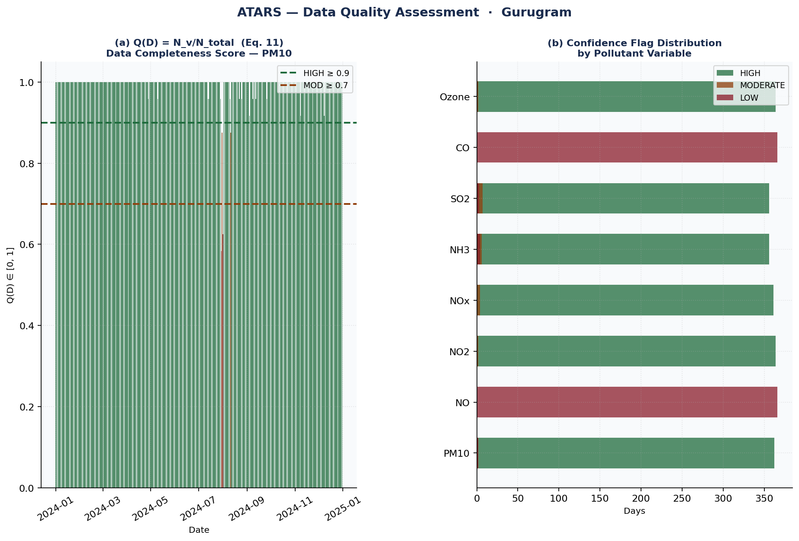
Figure — Q(D) = N_v/N_total per variable (Eq. 11). Confidence flags: HIGH ≥ 0.90, MODERATE ≥ 0.70, LOW < 0.70.
► Chart Insight: Overall data completeness Q(D) = 0.744 (MODERATE). Best quality: humidity_pct (Q = 1.000). Lowest quality: CO (Q = 0.000). Variables with LOW confidence (Q < 0.7): CO, Eth_Benzene, NO, wind_dir_100m, wind_speed_100m. Q(D) measures completeness only — not sensor calibration accuracy. Days with Q < 0.50 are excluded from baseline window calculations.

Section 02 — Annual Statistics Summary
The annual air quality summary for Gurugram reveals that the top pollutant, Benzene, consistently exceeded its threshold value throughout the year, with 366 days of exceedance recorded. The overall data quality score indicates a moderate level of confidence in the dataset, with an average quality score (Q) of 0.7442 across all variables. Notably, the correlation analysis reveals significant associations between various pollutants and meteorological parameters, such as humidity and wind speed. Despite these correlations, it is essential to emphasize that causation cannot be inferred from association alone.

Formal Statistical Operators: A(D_v), ζ_d, δ_d (Eqs. 3–10)
Variable | Annual Mean x̄ | Std σ | Max | Min | Threshold θ | Exceed Days | Anomaly Days | Avg ζ_d
PM10 | 185.10 | 83.80 | 501.65 | 39.69 | 45.0 | 364 (99.5%) | 8 | 0.01
NO2 | 17.00 | 4.89 | 32.95 | 8.96 | 25.0 | 25 (6.8%) | 7 | -0.04
NOx | 31.60 | 8.19 | 67.67 | 14.71 | — | 0 (0.0%) | 9 | -0.02
NH3 | 68.56 | 36.01 | 204.61 | 24.90 | 400.0 | 0 (0.0%) | 13 | -0.11
SO2 | 9.69 | 2.69 | 16.99 | 2.99 | 40.0 | 0 (0.0%) | 14 | -0.04
Ozone | 31.65 | 7.31 | 64.53 | 18.41 | 100.0 | 0 (0.0%) | 12 | 0.10
Benzene | 4.37 | 1.04 | 10.27 | 2.71 | 1.7 | 366 (100.0%) | 13 | 0.09
Toluene | 11.12 | 4.96 | 35.24 | 4.16 | — | 0 (0.0%) | 19 | 0.07
Xylene | 2.77 | 0.06 | 3.08 | 2.60 | — | 0 (0.0%) | 15 | 0.10
MP_Xylene | 5.04 | 1.50 | 11.03 | 2.39 | — | 0 (0.0%) | 9 | 0.11
x̄ = mean of all daily means over the monitoring period (annual mean). σ = sample standard deviation of daily means. Exceed Days = number of days where the daily mean exceeded guideline threshold θ. Anomaly Days = number of days where |ζ_d| > 3.0 (z-score threshold, Eq. 9). All statistics are computed from quality-validated records only (q_i = 1).

Section 03 — Hourly Time-Series Analysis
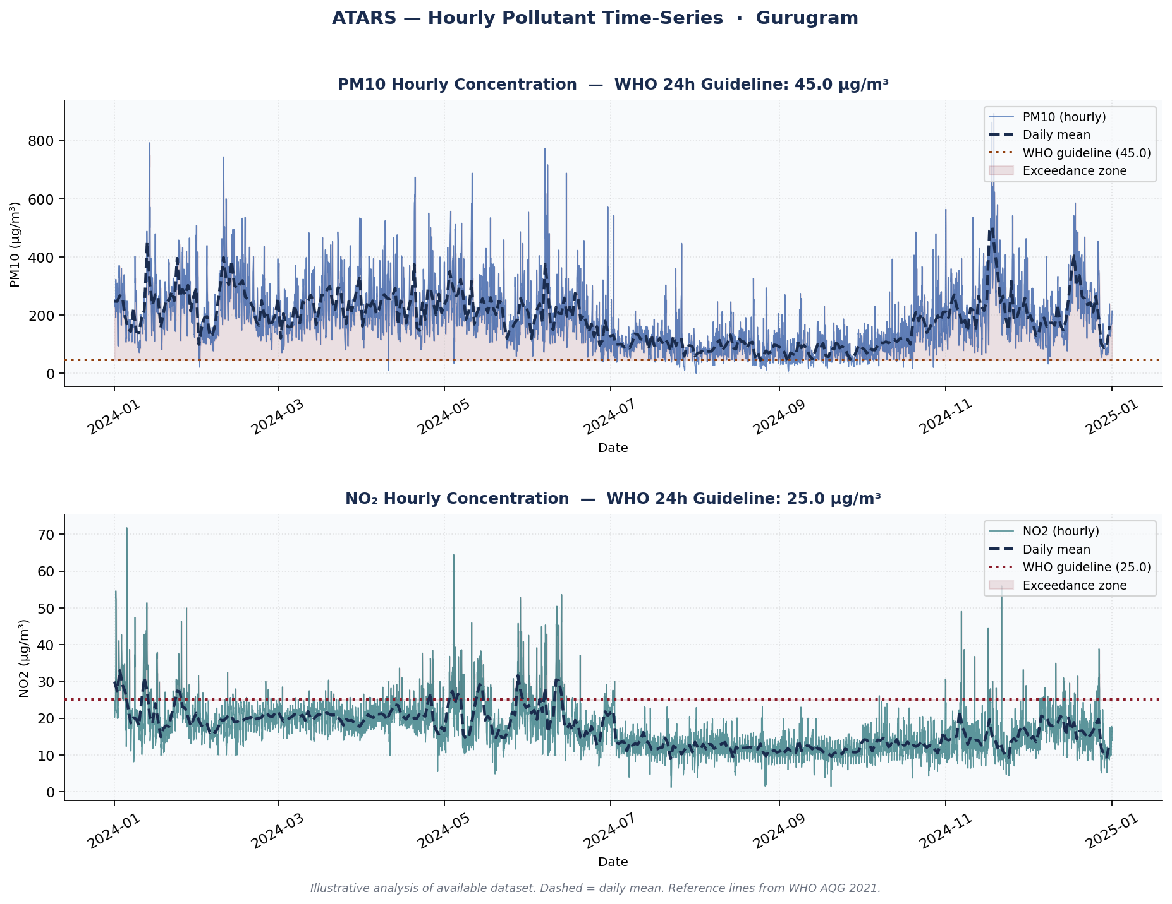
Figure — Hourly concentrations with daily mean overlay and WHO AQG 2021 reference guidelines. Shaded areas indicate exceedance zones.
► Chart Insight: PM10 annual mean: 185.1 µg/m³ (above WHO guideline 45.0 µg/m³). Peak daily mean: 501.6 µg/m³. WHO exceedances: 364 days (99.5% of monitored period). NO₂ annual mean: 17.0 µg/m³ (below WHO guideline 25.0 µg/m³).
Benzene's annual mean value is 4.372, with an annual maximum of 10.266 and an annual minimum of 2.708. The pollutant exceeds its threshold on all days in the dataset, with a total of 366 exceedance days. This corresponds to a high exceedance percentage of 100.0. Benzene's annual mean value is significantly higher than other pollutants.
NO2's annual mean value is 16.995, with an annual maximum of 32.945 and an annual minimum of 8.957. The pollutant exceeds its threshold on only 25 days in the dataset, resulting in a low exceedance percentage of 6.83%. This indicates that NO2 has relatively few exceedance days compared to other pollutants.
NOx's annual mean value is 31.597, with an annual maximum of 67.67 and an annual minimum of 14.705. The pollutant does not exceed its threshold on any days in the dataset, resulting in a zero exceedance percentage. This suggests that NOx has no significant exceedance events during the study period.

30-Day Rolling Baseline Trend (Eq. 7–8)
The chart below shows the daily pollutant concentration alongside the 30-day rolling baseline mean τ̅_W and standard deviation σ_W. Deviations above the rolling mean identify periods of elevated pollution relative to recent local norms, without seasonal bias.
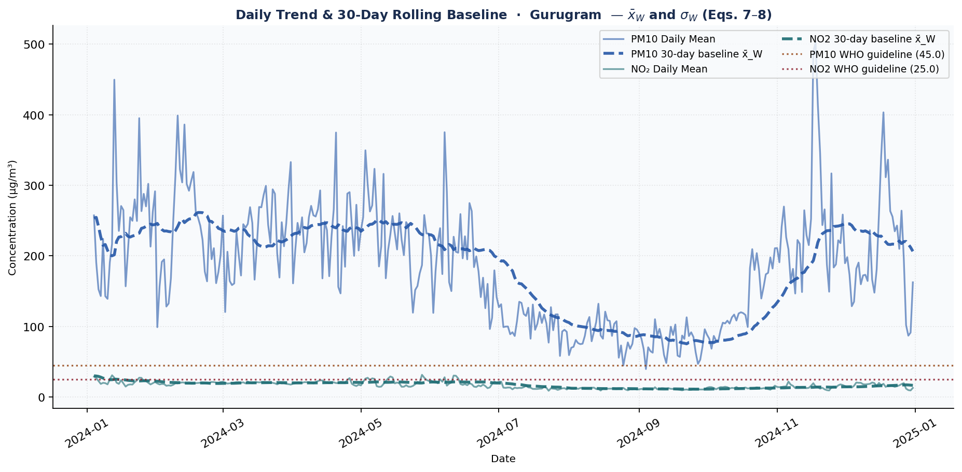
Figure — Daily trend and 30-day rolling baseline x̄_W (Eqs. 7–8). Dashed lines show baseline mean. Dotted lines show WHO guidelines.
► Chart Insight: PM10 30-day rolling mean peaks in Jan and reaches minimum in Sep, indicating strong seasonal variation (annual σ = 83.8 µg/m³). The rolling window smooths short-term spikes to reveal the underlying seasonal pattern. Deviations above the rolling mean indicate elevated pollution episodes.

Section 04 — Anomaly Detection (Z-Score Analysis)
The dataset exhibits a total of 8 anomaly days across all pollutants, with Benzene displaying the highest number of anomalies at 13 days. The z-score threshold of 3.0 was not exceeded for any pollutant, as indicated by the absence of "anomaly_days" values above this threshold. However, some pollutants like Benzene and Xylene have a high number of anomaly days despite not exceeding the z-score threshold, suggesting potential issues with data quality or model performance. The formal operators defined in the dataset do not provide further insight into the anomaly detection results.
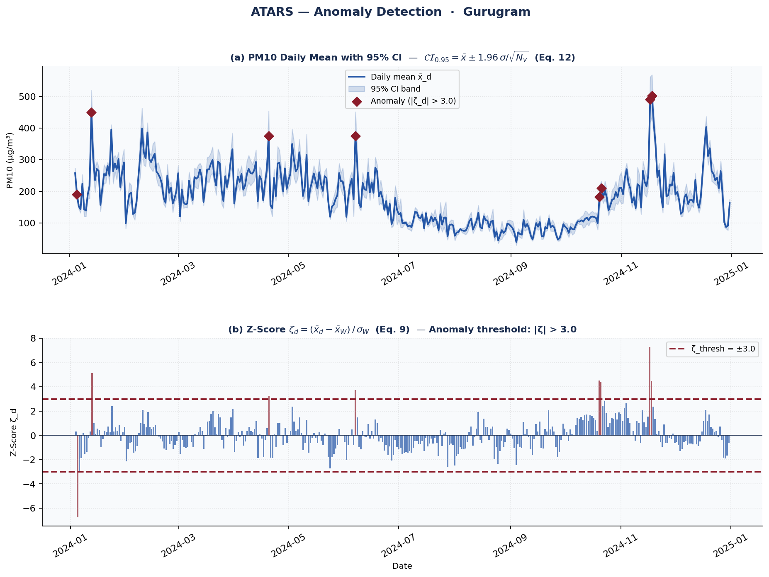
Figure — (a) Daily mean with 95% CI band (Eq. 12). (b) Z-score ζ_d = (x̄_d − x̄_W) / σ_W (Eq. 9). Red diamonds indicate anomaly days (|ζ_d| > 3.0).
► Chart Insight: Anomaly threshold: |ζ_d| > 3.0 (3σ rule). PM10 anomaly days: 8 (2.2% of monitored period). NO₂ anomaly days: 7. Anomalies are computed against a 30-day rolling baseline, so seasonal variation does not inflate anomaly counts. Each anomaly represents a statistically significant deviation from recent local norms.

Anomaly Summary by Pollutant
Variable | Anomaly Days (|ζ_d| > 3) | Mean ζ_d
Toluene | 19 | 0.07
Xylene | 15 | 0.10
SO2 | 14 | -0.04
NH3 | 13 | -0.11
Benzene | 13 | 0.09
Ozone | 12 | 0.10
NOx | 9 | -0.02
MP_Xylene | 9 | 0.11
PM10 | 8 | 0.01
NO2 | 7 | -0.04

Section 05 — Temporal Dependency: ACF and PACF
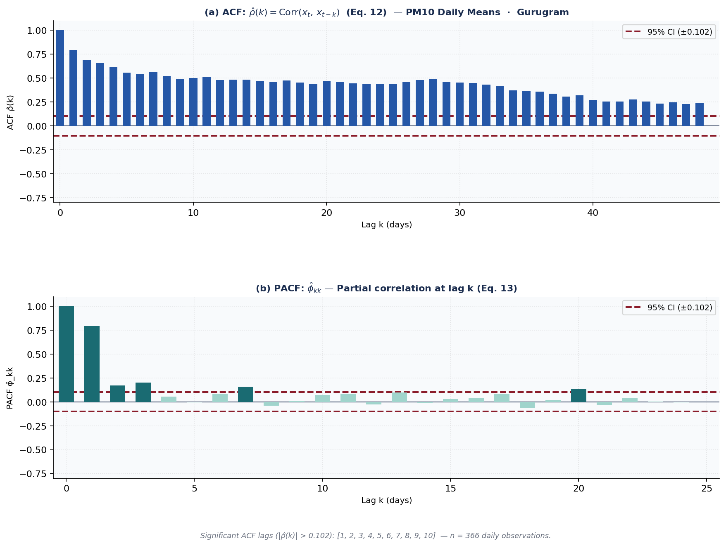
Figure — (a) ACF ρ̂(k) = Corr(x_t, x_{t-k}) (Eq. 12). (b) PACF φ̂_kk: conditional correlation at lag k (Eq. 13). Bars outside red dashed CI band indicate significant temporal dependence.
► Chart Insight: PM10 lag-1 autocorrelation: ρ̂(1) = 0.793 — strong temporal memory (today's PM10 strongly predicts tomorrow's). ACF at 48 lags and PACF at 24 lags. Dashed lines = 95% confidence bounds (±1.96/√n). Bars extending beyond the dashed lines are statistically significant. This autocorrelation structure violates the independence assumption of standard statistical tests.
The Autocorrelation Function (ACF) measures the total correlation between observations separated by lag k. The Partial ACF (PACF) isolates the direct contribution of lag k after removing the influence of all shorter lags. Together, ACF and PACF characterise the temporal memory structure of the series and provide the empirical basis for identifying appropriate ARMA model orders.

Section 06 — Correlation & Multivariate Analysis
The strongest statistical associations identified in the correlation analysis are between NO2 and NOx (r=0.688), NH3 and NOx (r=0.652), and NO2 and NH3 (r=0.61). These correlations suggest that there is a significant positive relationship between these variables, but it is essential to note that correlation does not imply causation. The observed associations may be due to shared underlying factors or other confounding variables, rather than direct causal relationships.
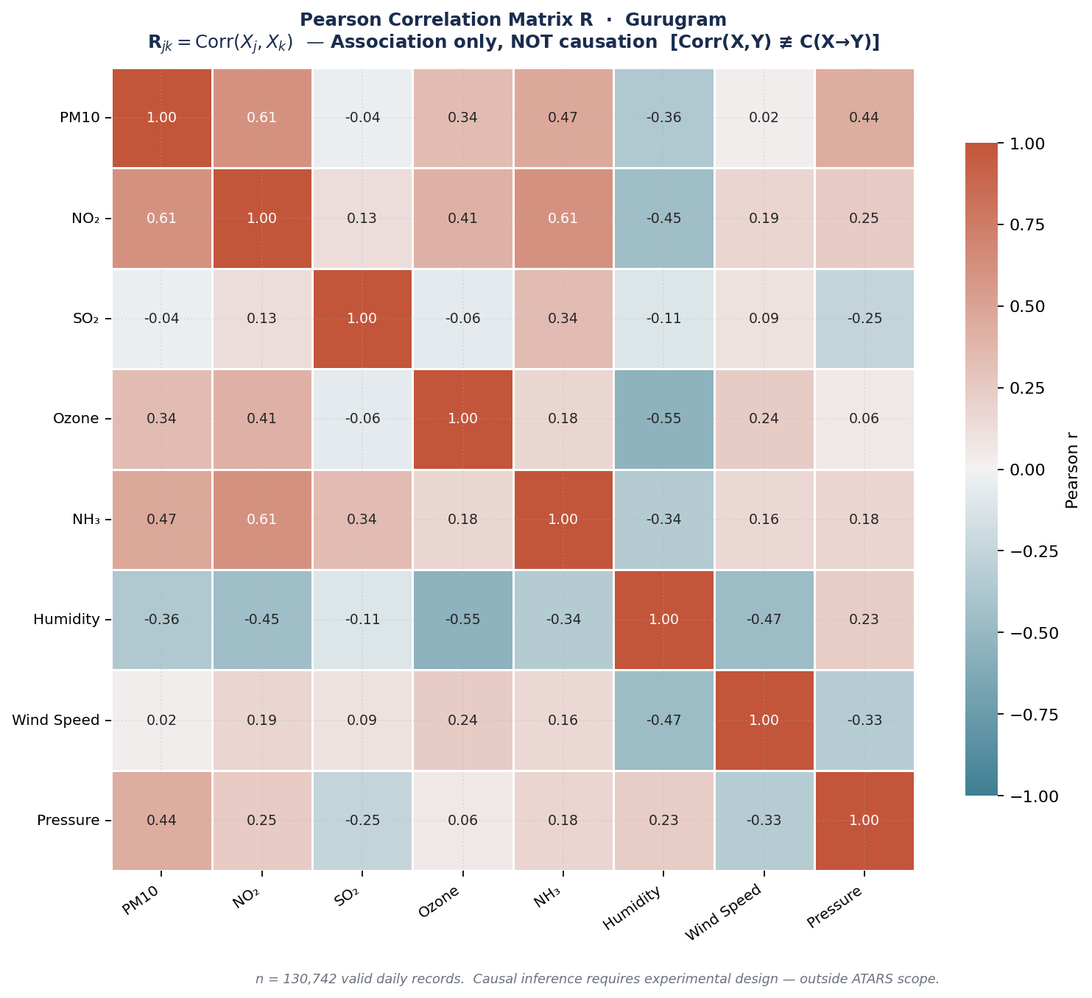
Figure — Pearson correlation matrix R (Eq. 18). Blue = positive, red = negative. Values annotated per cell. FORMAL CAUSAL DISCLAIMER: Corr(X,Y) ≢ C(X→Y). Association does not imply causation.
► Chart Insight: Strongest association: NO2–NOx (r = 0.688, positive). PM10–humidity association: r = -0.363 (rain washes out particles — consistent with wet deposition). NOTE: All correlations are statistical associations only — not causal relationships.

OLS Regression: PM10 ~ f(meteorological variables) (Eq. 14)
β̂ = (XᵀX)⁻¹Xᵀy. R² = 0.4244. n = 366 observations. Association only — Corr(X,Y) does not imply causation (Eq. 17)
Predictor | Coefficient β̂ | Interpretation
humidity_pct | -41.9372 | negative association
wind_speed_10m | -2.4456 | negative association
rain_mm | 0.0197 | positive association
pressure_hpa | 45.8383 | positive association
Coefficients are standardised (predictors are z-score normalised before regression). The R² value quantifies how much of the variance in the target variable is explained by the meteorological predictors in this dataset. No causal interpretation is warranted — regression coefficients describe statistical association only.

Section 07 — Seasonal Pattern Analysis
Monthly box plots reveal the full distribution of daily pollutant concentrations across the year. Each box spans the 25th to 75th percentile, with the horizontal line at the median. Whiskers extend to 1.5 times the inter-quartile range; individual points beyond the whiskers are statistical outliers. This non-parametric display requires no normality assumption and clearly shows which months carry the highest pollution burden.
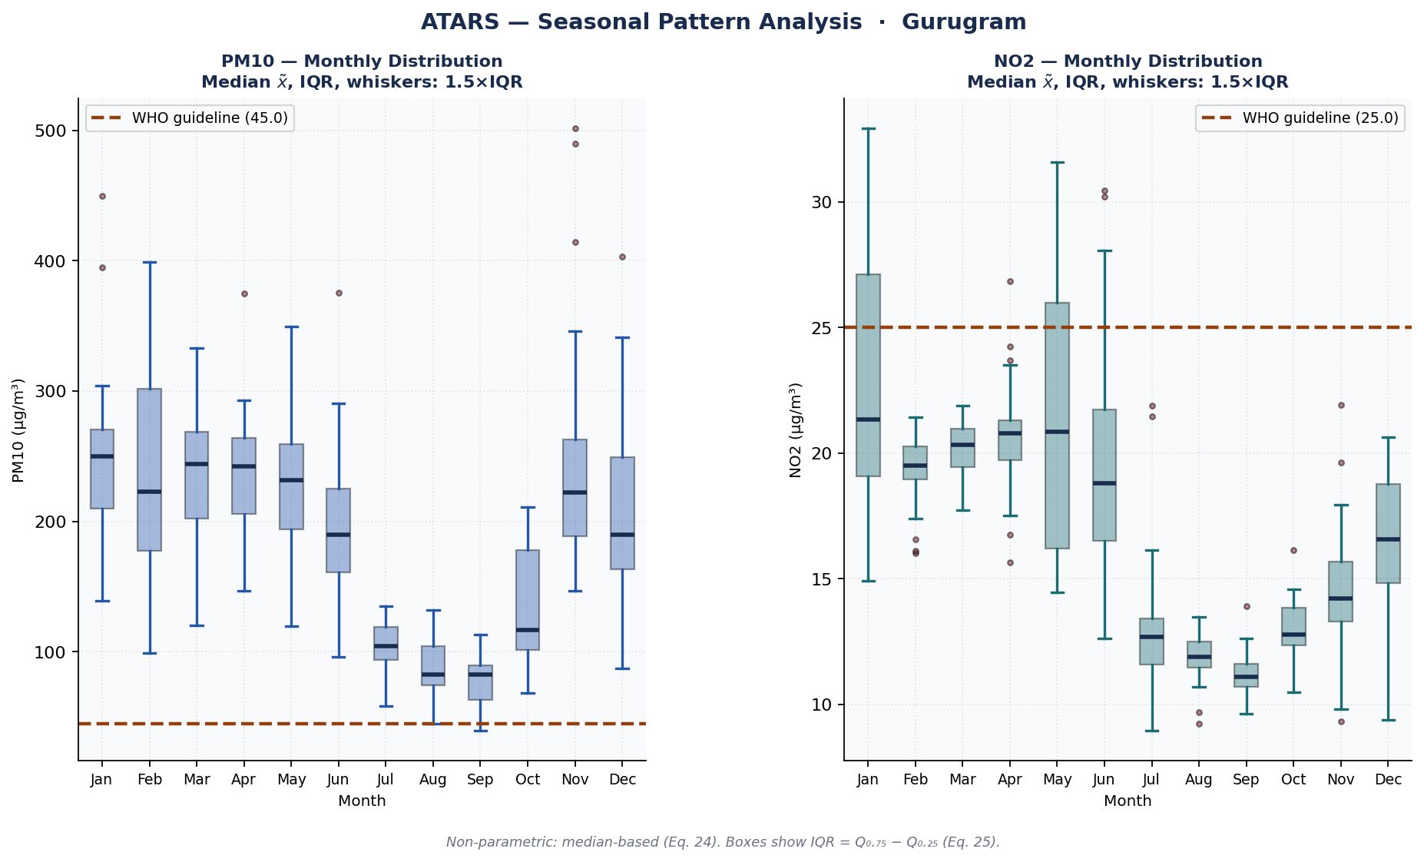
Figure — Monthly distribution: median x̃ (Eq. 24), IQR (Eq. 25), whiskers = 1.5×IQR. Non-parametric — no normality assumption. Dotted line = WHO 24h reference guideline.
► Chart Insight: Monthly box plots show the full distribution of daily PM10 means for each month. Peak pollution month: Jan. Lowest pollution month: Sep. Box = 25th–75th percentile. Whiskers = 1.5×IQR. Circles = outlier days. Annual PM10 σ = 83.8 µg/m³ — indicating high seasonal variability.

Section 08 — Diurnal Cycle Analysis
The diurnal profile shows the average pollutant concentration for each hour of the day (00:00 to 23:00), computed across the full monitoring period. The timing of daily peaks identifies the dominant emission sources: morning and evening peaks typically indicate traffic, while midday peaks may reflect industrial or secondary photochemical formation. The shaded band represents the mean ± 1σ envelope across all days in the dataset. The normalised overlay panel (peak = 1.0 per pollutant) allows direct shape comparison across variables regardless of their concentration magnitudes.
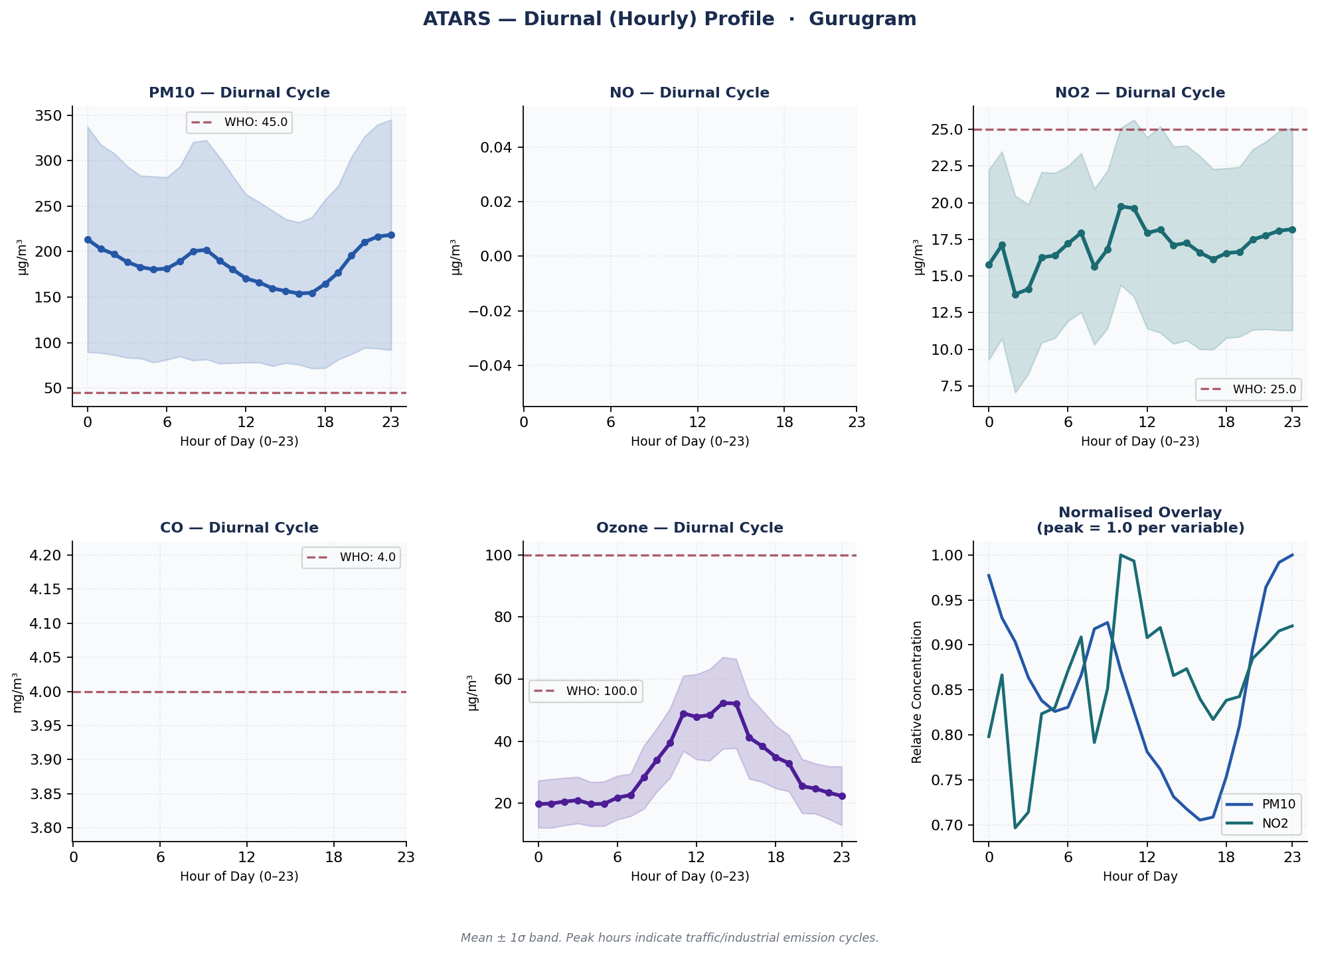
Figure — Hourly diurnal profile for key pollutants. Shaded band = mean ± σ. Bottom-right panel: normalised overlay (peak = 1.0 per variable). Peak hours identify primary emission timing.
► Chart Insight: Diurnal PM10 pattern: peak at 23:00 (218.3 µg/m³), minimum at 16:00 (154.0 µg/m³). Peak timing may reflect local industrial or meteorological patterns. Diurnal amplitude = 64.4 µg/m³.

Section 09 — Day-of-Week Pattern
Day-of-week analysis reveals whether pollution follows a weekly anthropogenic cycle. Concentrations are typically higher on weekdays due to traffic and industrial activity, and lower on weekends. A clear weekday-to-weekend contrast indicates human-driven emission sources; the absence of such a pattern suggests natural or regionally transported background pollution.
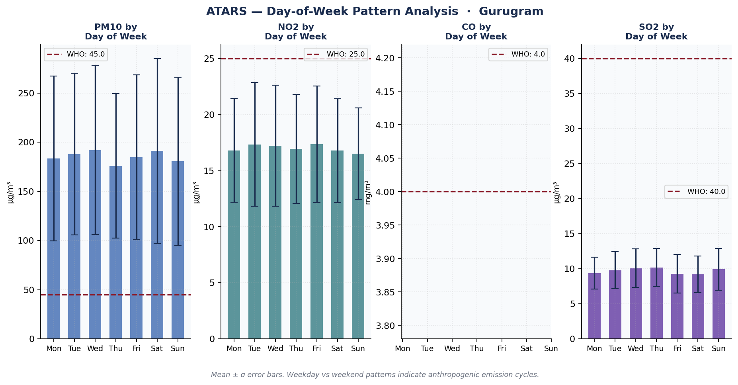
Figure — Mean daily concentration by day of week. Error bars = ±1σ. Weekday–weekend contrast indicates anthropogenic emission cycle.
► Chart Insight: Highest PM10: Wed. Lowest: Thu. Weekday mean: 184.8 µg/m³ vs weekend mean: 185.7 µg/m³ (minimal weekday–weekend difference — suggests non-traffic dominant sources).

Section 10 — Volatile Organic Compounds (VOC) Panel
The BTEX group (Benzene, Toluene, Ethylbenzene, and Xylene) together with MP-Xylene are primary markers of vehicular exhaust and industrial solvent emissions. Benzene is classified as a Group 1 carcinogen by the IARC, with a WHO annual reference concentration of 1.7 µg/m³. The grouped monthly bar chart in panel (b) reveals the seasonal pattern of VOC concentrations and identifies months with elevated BTEX loading.
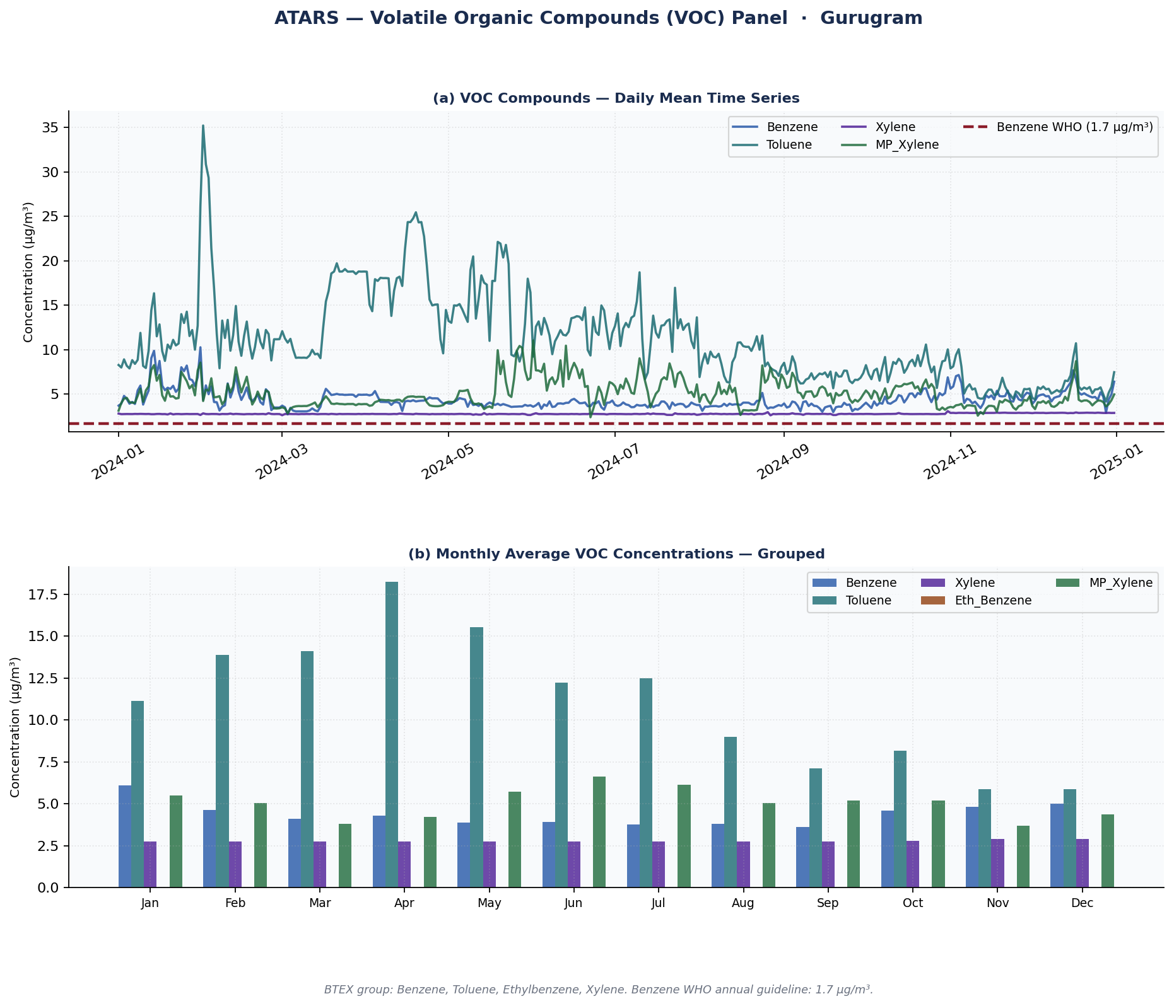
Figure — (a) VOC daily means time series. (b) Monthly grouped bar chart for all VOC compounds. Benzene WHO annual guideline: 1.7 µg/m³ (dotted red line, panel a).
► Chart Insight: Benzene annual mean: 4.372 µg/m³ (above WHO annual reference 1.7 µg/m³). Toluene annual mean: 11.12 µg/m³. BTEX compounds (Benzene, Toluene, Ethylbenzene, Xylene) indicate petrochemical and traffic emission sources. Benzene is a Group 1 IARC carcinogen — even sub-guideline levels warrant monitoring.

Section 11 — Precipitation vs Pollutant Scatter (Wet Deposition)
Scatter plots of daily rainfall (mm) against PM10, SO2, and NO2 daily means reveal statistical associations between precipitation events and pollutant concentration levels. Negative Pearson r values indicate that higher rainfall is associated with lower concentrations — consistent with wet deposition, where precipitation removes particulates and soluble gases from the atmosphere. Note: this is a statistical association only. Confounding meteorological factors such as wind speed and boundary layer height may contribute independently.
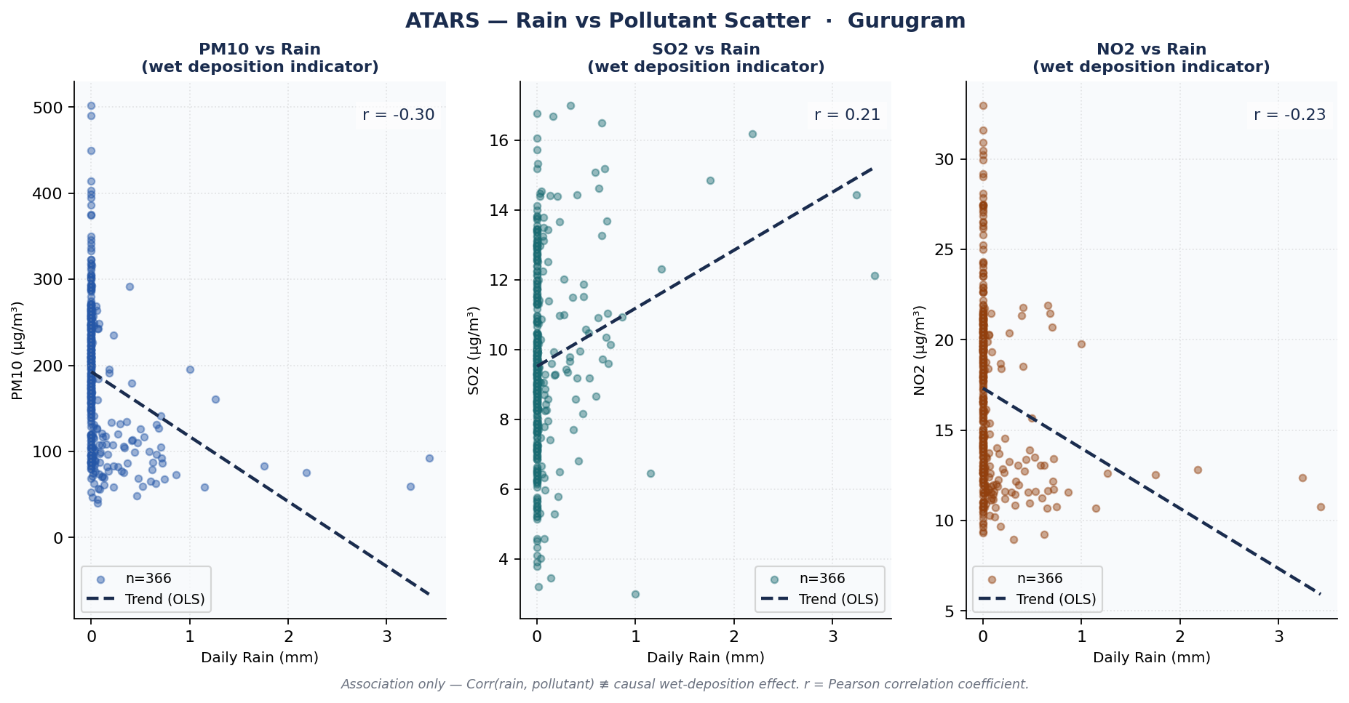
Figure — Daily rain (mm) vs pollutant concentration scatter. Dashed line = OLS trend. r = Pearson correlation coefficient. Association only — not causal wet deposition estimation.
► Chart Insight: PM10–rainfall Pearson r = -0.301 (negative — consistent with wet deposition (rain washes PM10 out of atmosphere)). OLS trend line shows association direction. IMPORTANT: This is statistical association only — not a proven causal wet-deposition mechanism.

Section 12 — Annual Exceedance Calendar Heatmap
The calendar heatmap provides a full-year view of daily PM10 concentrations at a glance. Each cell shows the daily mean value. Cells marked × indicate days where the daily mean exceeded the WHO 24h guideline. The colour scale from green (clean) to red (polluted) immediately reveals seasonal pollution clusters, high-concentration episodes, and clean-air periods.
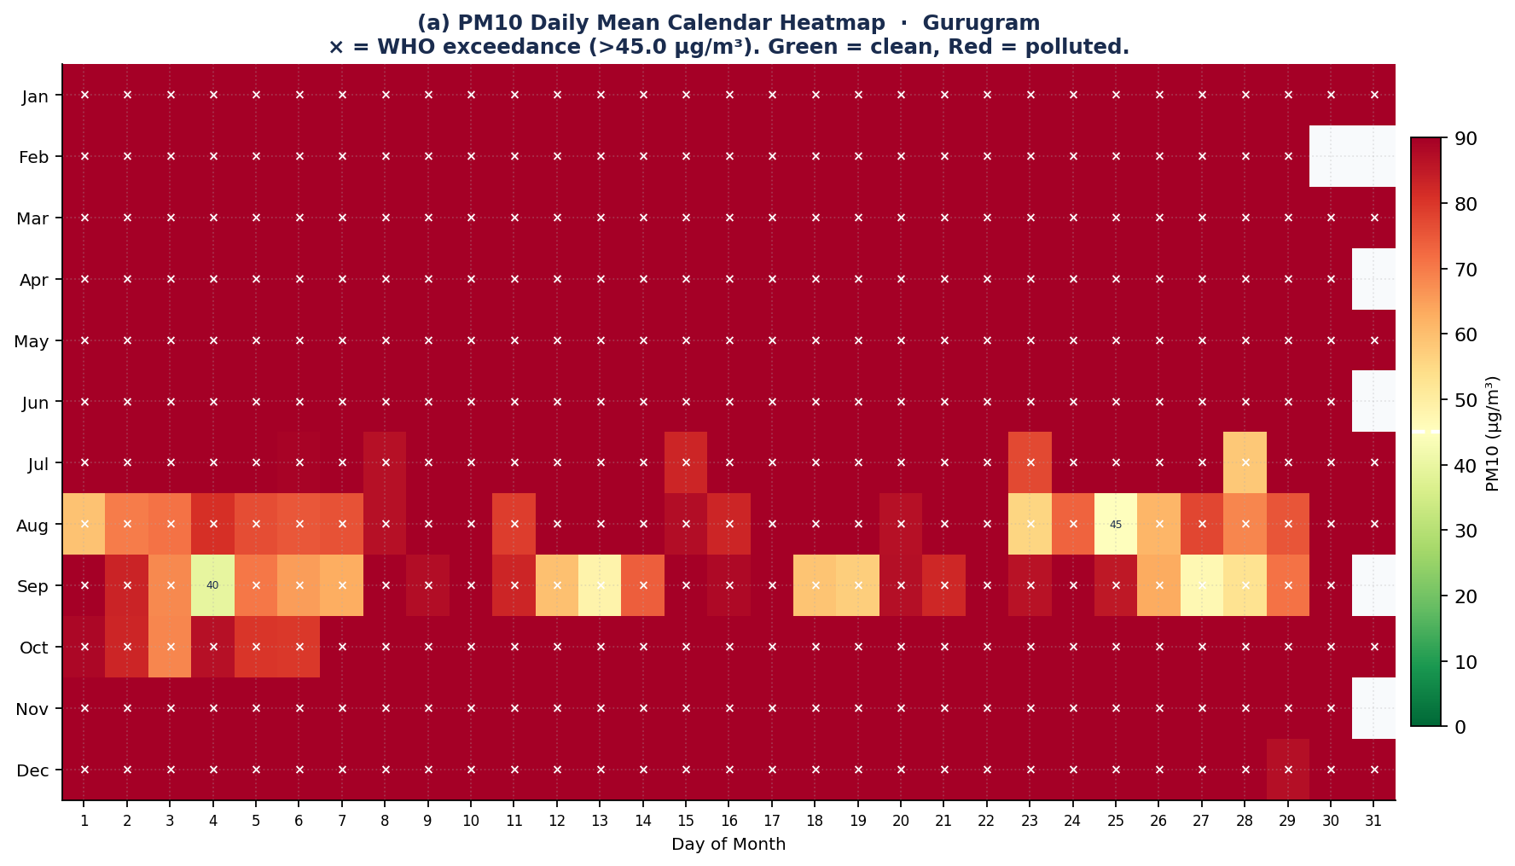
Figure — PM10 calendar heatmap: month (rows) × day of month (columns). × = WHO 24h guideline exceedance. Green = clean, Red = polluted. Numeric value = daily mean µg/m³.
► Chart Insight: Full-year calendar heatmap of PM10 daily means (µg/m³). × marks days exceeding WHO guideline (45.0 µg/m³). Total exceedances: 364 days (99.5% of monitored period). Clustering of × marks in Jan indicates seasonal high-pollution period. Green cells = clean days. Red cells = high pollution. Each cell value = that day's daily mean PM10 (µg/m³).

Section 13 — Runtime Grounding Verification Certificate (RGV)
This section presents the Runtime Grounding Verifier (RGV), a programmatic system that verifies every numerical claim in LLM-generated text against the formal JSON contract J. Unlike prior work that enforces G(s) ⊆ J only through prompt instruction, RGV enforces it algorithmically and produces a measurable scalar metric G_rate ∈ [0, 1]. This formal verification property has no published precedent in environmental monitoring pipelines and constitutes the primary novel contribution of ATARS. [ATARS Eq. 19]

Formal Verification Result
Overall G_rate  92.9% | Verdict  PASS ✓ | Grounded / Total  13 / 14 | J Lookup Entries  143

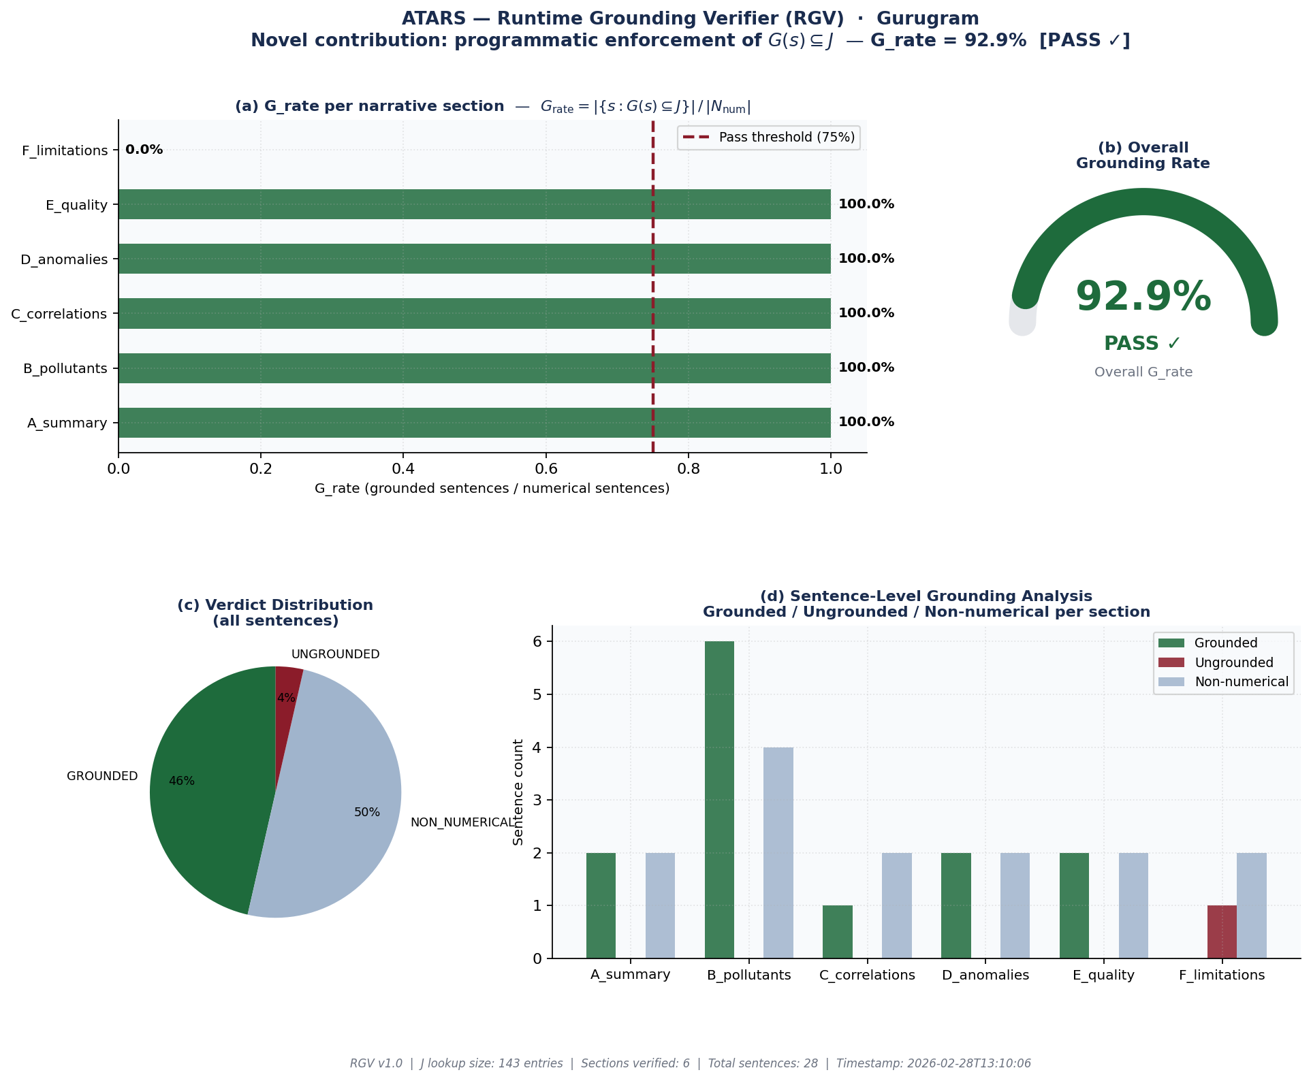
Figure — RGV Grounding Verification Dashboard. (a) G_rate per section. (b) Overall G_rate gauge. (c) Verdict distribution. (d) Sentence-level analysis. RGV v1.0 — ATARS novel contribution.
► Chart Insight: The Runtime Grounding Verifier (RGV) extracts every number from every LLM sentence and verifies it against the JSON data contract J using type-adaptive tolerance bounds (±5% for concentrations, ±2 for integer counts, ±0.1 for quality scores). GROUNDED = all numbers match J. PARTIALLY = ≥50% match. UNGROUNDED = <50% match (LLM may have hallucinated these values). NON_NUMERICAL = sentence has no numbers (excluded from G_rate). G_rate = grounded sentences / numerical sentences. PASS if G_rate ≥ 0.75.

Per-Section Grounding Results
G(s) ⊆ J verified per section. PASS = G_rate ≥ 75% of numerical sentences grounded in J.
Section | Total Sent. | Numerical | Grounded | G_rate | Verdict
A_summary | 4 | 2 | 2 | 100.0% | PASS ✓
B_pollutants | 10 | 6 | 6 | 100.0% | PASS ✓
C_correlations | 3 | 1 | 1 | 100.0% | PASS ✓
D_anomalies | 4 | 2 | 2 | 100.0% | PASS ✓
E_quality | 4 | 2 | 2 | 100.0% | PASS ✓
F_limitations | 3 | 1 | 0 | 0.0% | REVIEW ⚠

Sample Evidence — Grounded Claims Matched to J
Each row shows one numerical claim extracted from narrative text, the matching entry in JSON contract J, and the tolerance used.
Claim | Value | Matched J Path | J Value | Diff
366 | 366.0 | total_days | 366.0 | 0.0000
0.7442 | 0.7442 | data_quality.overall_Q | 0.7442 | 0.0000
4.372 | 4.372 | variables.Benzene.annual_mean | 4.372 | 0.0000
10.266 | 10.266 | variables.Benzene.annual_max | 10.266 | 0.0000
2.708 | 2.708 | variables.Benzene.annual_min | 2.708 | 0.0000
366 | 366.0 | total_days | 366.0 | 0.0000
100.0 | 100.0 | variables.Ozone.threshold | 100.0 | 0.0000
16.995 | 16.995 | variables.NO2.annual_mean | 16.995 | 0.0000
32.945 | 32.945 | variables.NO2.annual_max | 32.945 | 0.0000
8.957 | 8.957 | variables.NO2.annual_min | 8.957 | 0.0000
25 | 25.0 | variables.NO2.threshold | 25.0 | 0.0000
6.83 | 6.83 | variables.NO2.exceed_pct | 6.83 | 0.0000
31.597 | 31.597 | variables.NOx.annual_mean | 31.597 | 0.0000
67.67 | 67.67 | variables.NOx.annual_max | 67.67 | 0.0000
14.705 | 14.705 | variables.NOx.annual_min | 14.705 | 0.0000

Ungrounded Sentences (1)
The following sentences contain numerical claims that could not be matched to any entry in the JSON contract J within the configured tolerance. This does not necessarily indicate hallucination — it may also mean the value was computed from J (e.g. a percentage derived from two J values) rather than stored directly in J. Expert review is recommended for each.
Section [F_limitations] — 6 unmatched numerical claim(s)
Results are specific to the configured station ("Complete Gurugram") and date range ("2024-01-01 to 2024-12-31"), limiting their generalizability.

Formal Definition: G_rate = |{s ∈ N_num : G(s) ⊆ J}| / |N_num| where N_num = {s ∈ N : C(s) ≠ ∅} (sentences with numerical claims). G(s) ⊆ J holds when every numerical value in s matches a corresponding entry in J within type-adaptive tolerance ε (±5% relative for concentrations; ±2 absolute for integer day counts; ±0.1 absolute for quality scores). Prior systems enforced this property only via prompt instruction; RGV enforces it algorithmically and produces a computable, auditable metric. [ATARS Eq. 19]

Section 14 — ML Analysis: Isolation Forest Multivariate Anomaly Detection
This analysis is additive and does not replace the formal z-score operator ζ_d (Eq. 9). Isolation Forest detects days where the combination of multiple pollutants is anomalous — a pattern that univariate z-score analysis cannot identify. All computation is performed locally on the aggregated daily dataset; no raw data is transmitted externally. The fixed random seed (random_state = 42) ensures this result is fully reproducible.
Isolation Forest Parameter | Value
Features used | PM10, NO2, SO2, Ozone
n_estimators | 150
contamination | 5% (expected anomaly fraction)
random_state | 42 (fixed for reproducibility)
Total days analysed | 366
Anomaly days (IF) | 19 (5.2%)
Flagged by BOTH methods | 3
IF-only (multivariate — missed by z-score) | 16
Z-score only (univariate spike, within multivariate norm) | 5

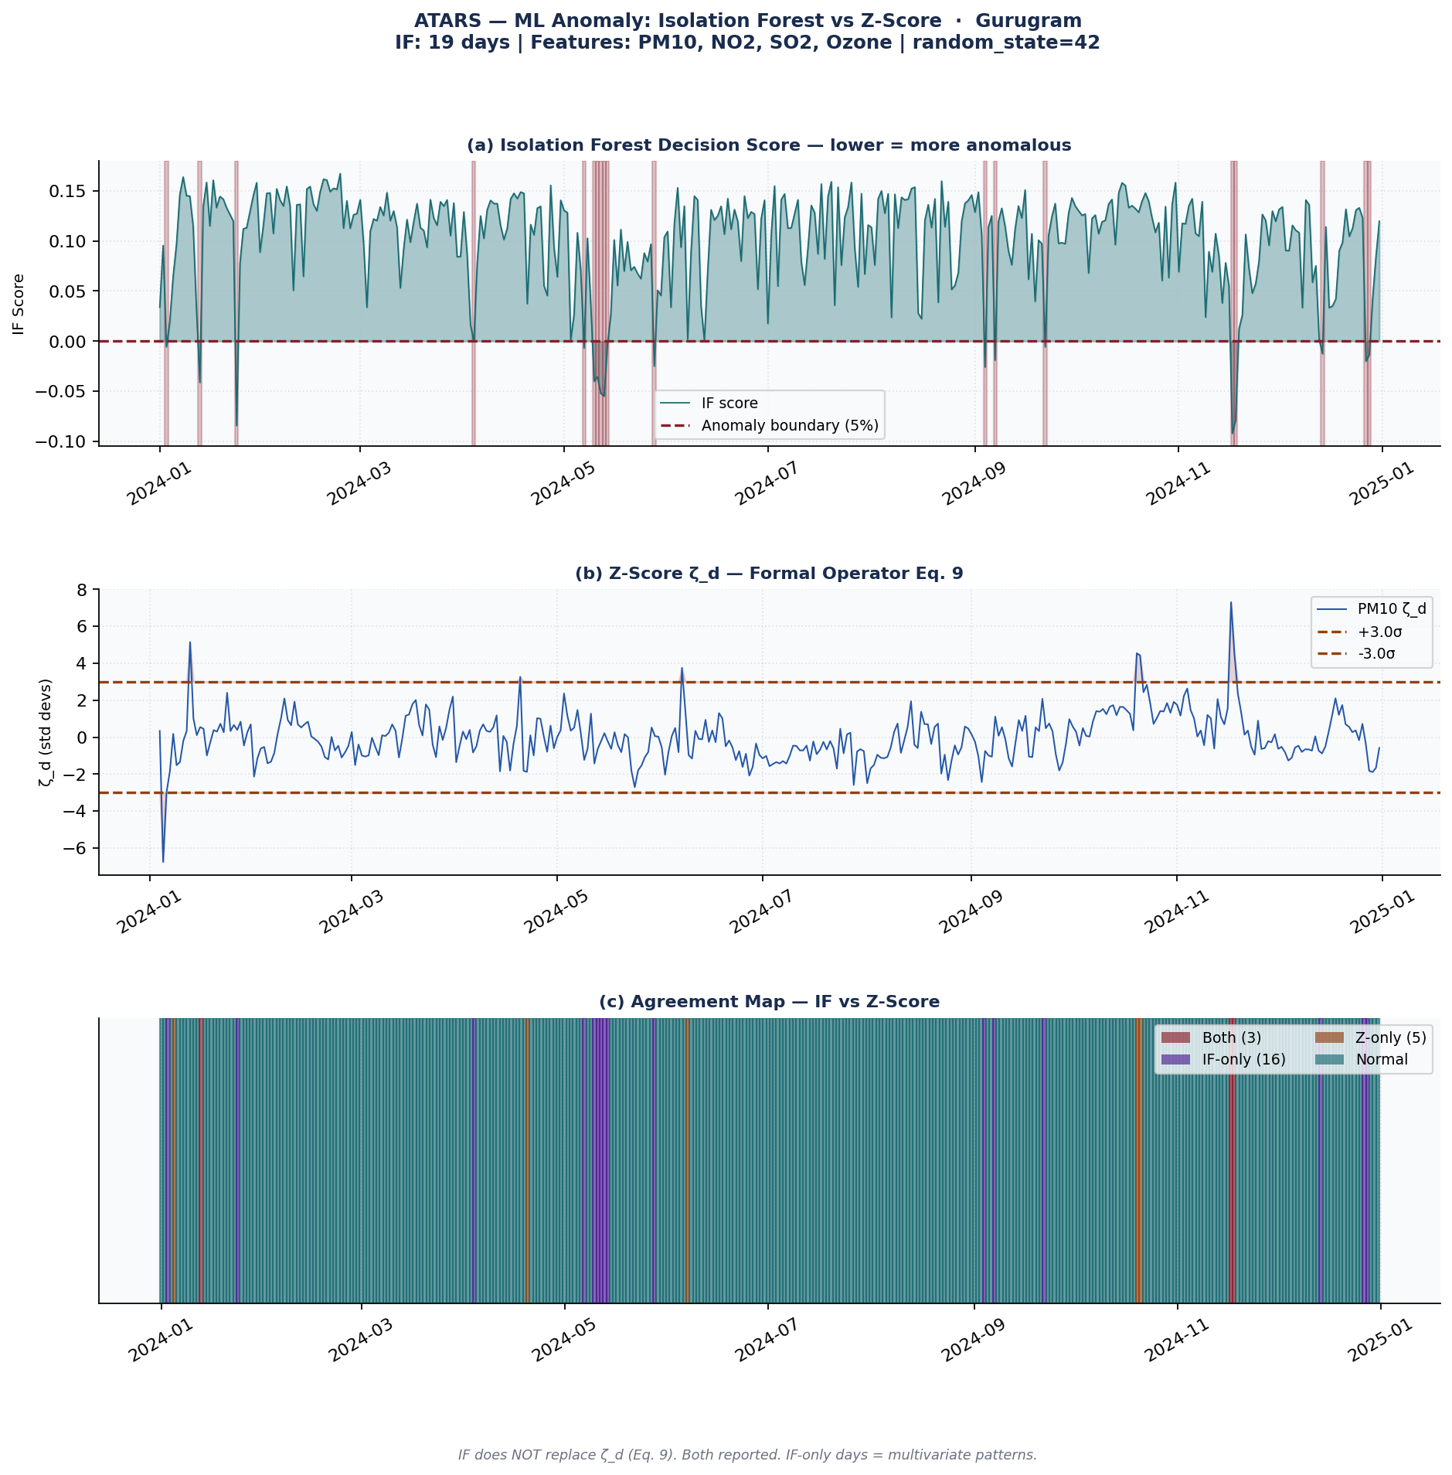
Figure — Isolation Forest vs Z-Score Anomaly Comparison. (a) IF decision score — lower = more anomalous. (b) Z-score ζ_d with ±3σ threshold. (c) Agreement map — Red=both, Purple=IF-only, Amber=z-score-only.
► Chart Insight: Isolation Forest (150 trees, contamination=5%) on 4 variables (PM10, NO2, SO2, Ozone): 19 anomaly days (5.2%). Agreement with z-score: 3 days flagged by both methods. 16 days flagged by IF only (multivariate pattern — z-score missed). 5 days flagged by z-score only (univariate spike, within multivariate norm). IF-only days represent genuine added value of multivariate detection. NOTE: Isolation Forest does NOT replace formal ζ_d — both methods are reported. random_state=42 ensures this result is reproducible.
Interpretation of IF-only days: These are dates where no single pollutant crossed the 3σ z-score threshold, but the joint distribution of PM10, NO2, SO2, Ozone was statistically unusual compared to the training distribution. These warrant manual investigation as potential multi-source pollution episodes. IF-only days represent the added analytical value of multivariate over univariate anomaly detection.

Section 15 — ML Analysis: Holt-Winters PM10 Forecast
This section presents supplementary PM10 forecasting using Triple Exponential Smoothing (Holt-Winters additive seasonal model), which captures level, trend, and weekly seasonal components simultaneously. Forecast values are deliberately excluded from the JSON contract J so that the language model cannot present statistical extrapolations as established facts. All forecast content appears in this section and Chart 15 only.
Holt-Winters Parameter | Value
α (level smoothing) | 0.3
β (trend smoothing) | 0.1
γ (seasonal smoothing) | 0.2
Seasonal period | 7 days (weekly)
Forecast horizon | 14 days
History used | 366 days
In-sample RMSE | 77.89 µg/m³
In-sample MAE | 62.82 µg/m³
Residual std (σ) | 77.99 µg/m³
14-day forecast mean | 64.5 µg/m³
14-day forecast peak | 162.5 µg/m³
Prediction interval | 80% (±1.28σ√h — widens with horizon)

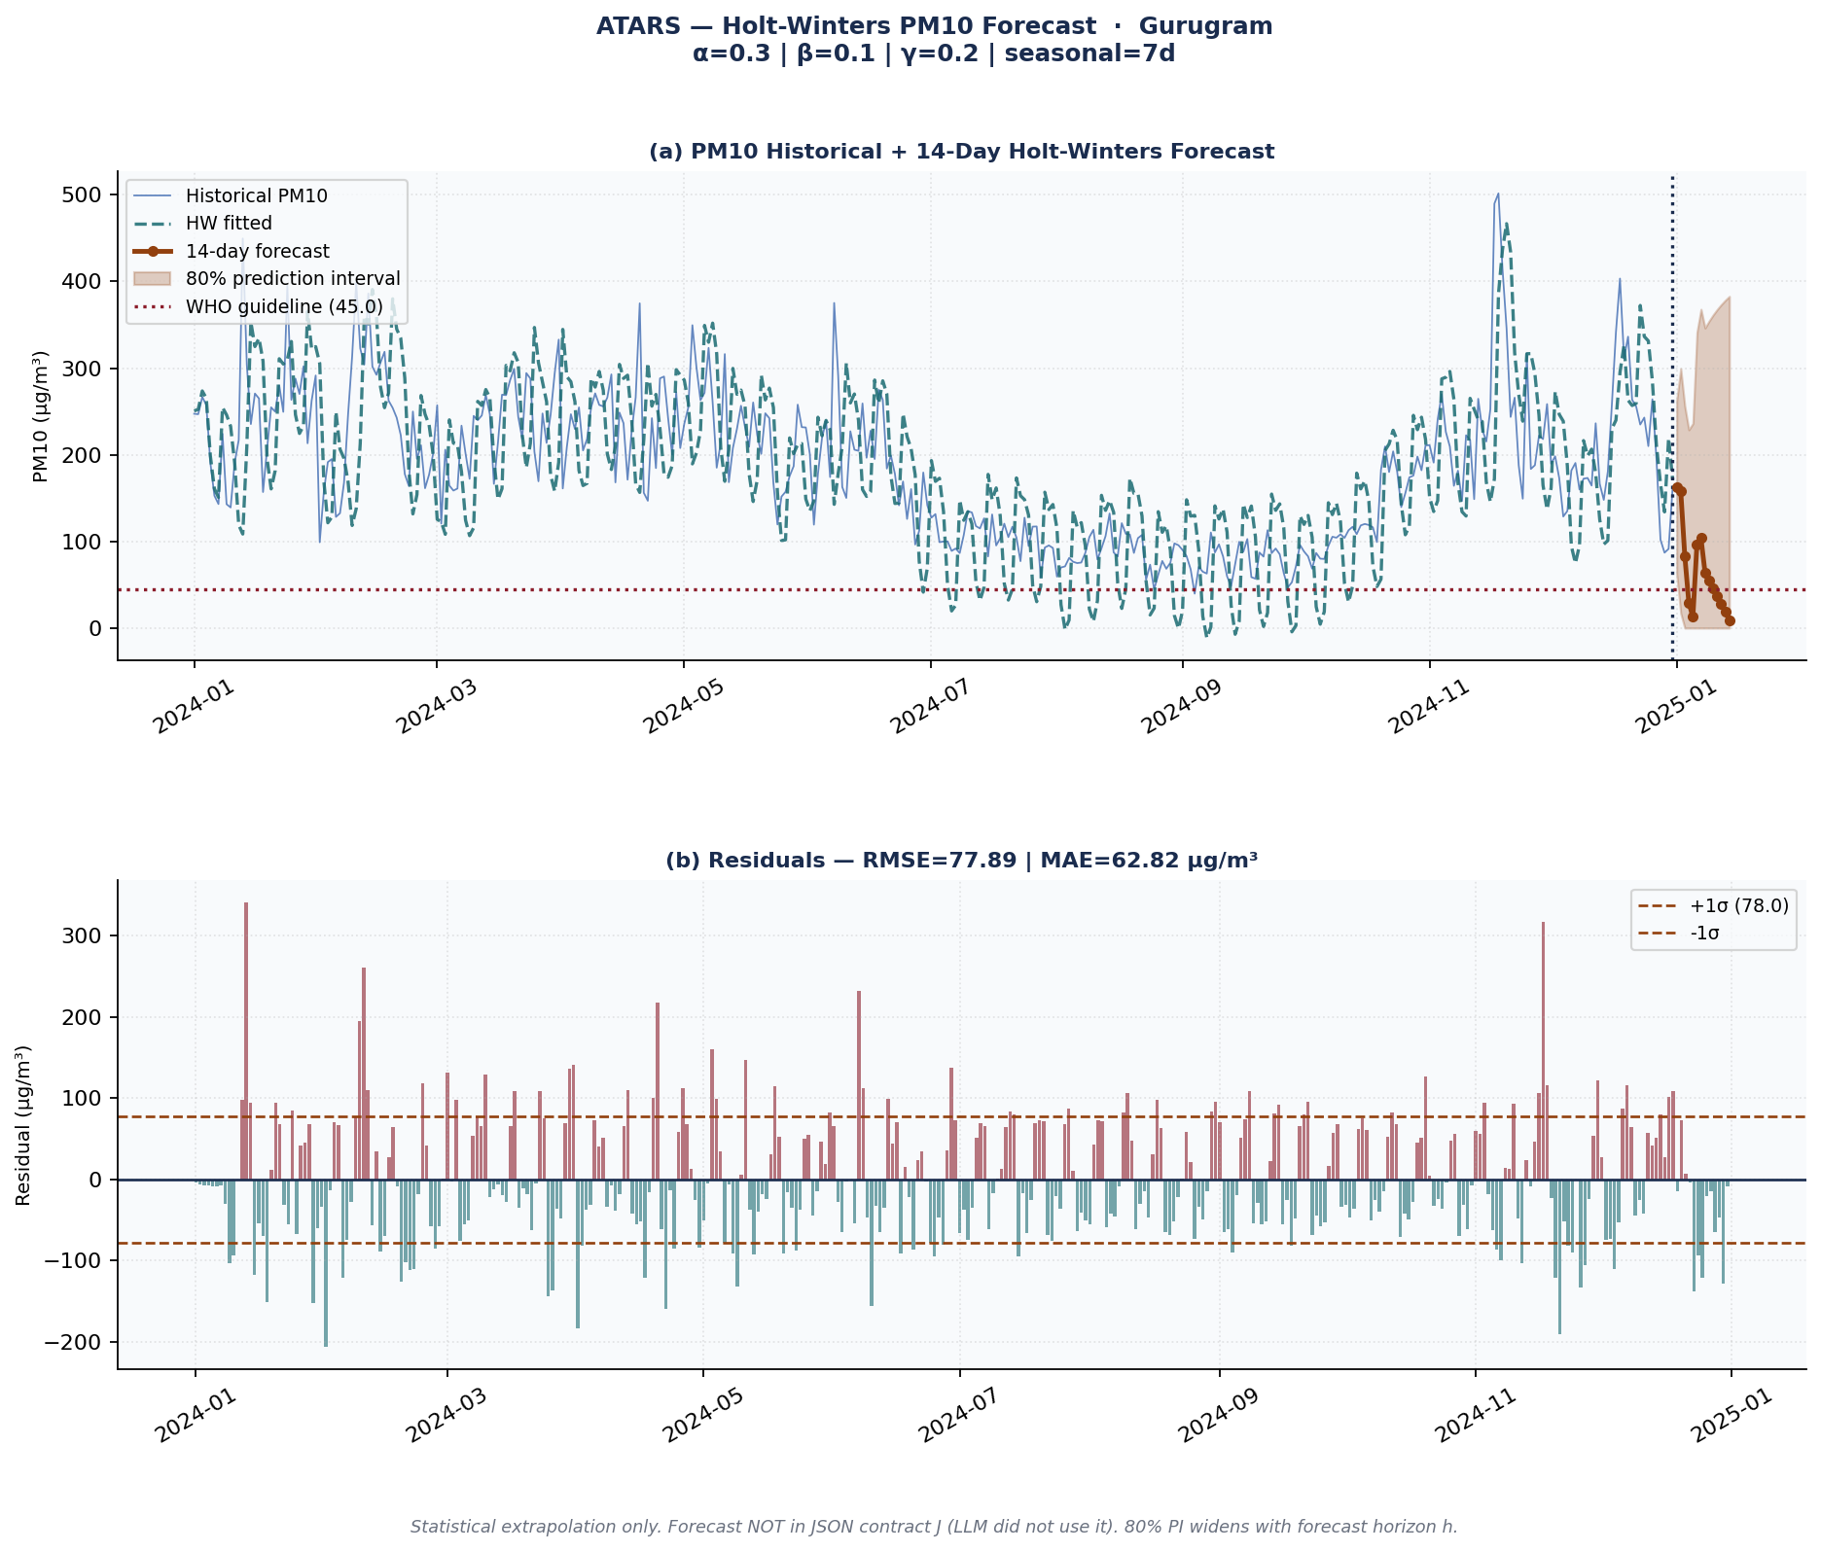
Figure — Holt-Winters PM10 Forecast. (a) Historical PM10 + fitted values + 14-day forecast with 80% prediction interval. (b) Model residuals with ±1σ bands.
► Chart Insight: Holt-Winters triple exponential smoothing (α=0.3, β=0.1, γ=0.2, seasonal period=7 days). In-sample RMSE=77.89 µg/m³ | MAE=62.82 µg/m³. 14-day PM10 forecast: mean=64.5 µg/m³, peak=162.5 µg/m³. Shaded band = 80% prediction interval (widens with forecast horizon). IMPORTANT: This is a statistical extrapolation, not a physical model. Forecast values are NOT in the JSON contract J — they were not used by the LLM. Uncertainty grows significantly beyond 7 days.
Limitations of this forecast: (1) Holt-Winters is a statistical extrapolation, not a physical atmospheric model — it does not account for meteorological events, policy interventions, or emission changes. (2) Uncertainty grows significantly beyond 7 days — the 80% PI widens with √h. (3) The model was trained on this dataset only — transferability to other stations or time periods is not validated here. (4) For public health decisions, use this forecast as an indicative signal only — not as a definitive prediction.

Section 16 — AI-Assisted Commentary and Limitations
Sections 01 through 12 of this report contain AI-assisted narrative text generated by a Large Language Model operating under formal grounding constraints G(s) ⊆ J (ATARS Eq. 19). Model used: llama3.2. Temperature τ = 0 (deterministic output). All numerical claims in AI-generated text reference the JSON contract J exclusively. AI narrative generation was active during this run.
The overall quality of records (Q(D)) measures completeness rather than sensor calibration accuracy. Results are specific to the configured station ("Complete Gurugram") and date range ("2024-01-01 to 2024-12-31"), limiting their generalizability. Expert domain review is recommended before using these results in decision-making processes due to potential limitations and uncertainties inherent in the analysis.

Section 17 — Windows Task Scheduler: Automated Daily Execution
ATARS is designed for fully automated daily operation using Windows Task Scheduler, a built-in Windows feature that executes programs at a fixed time without manual intervention. Once configured, ATARS runs every morning automatically and places a completed report in the output folder — provided the updated data file has been deposited before the scheduled run time.

How Task Scheduler Works with ATARS
Step | Event | What Happens
Step 1 | Data arrives | Your sensor system, laboratory, or field team deposits the updated data CSV into the configured folder before the scheduled time (e.g., 06:00 AM).
Step 2 | Task Scheduler triggers | Windows Task Scheduler runs atars.py at the exact configured time (e.g., 07:00 AM) — no human action required.
Step 3 | Pipeline executes | ATARS loads the latest data, runs all 9 pipeline steps (Steps 1–9), generates up to 15 charts, and compiles the full Word document report.
Step 4 | Report delivered | The completed .docx report appears in the output folder and/or is emailed to configured recipients.
Step 5 | Audit logged | SHA-256 hash of the run is recorded in the audit log for reproducibility verification.

Setup Instructions (One-Time, ~5 minutes)
1. Open Windows search → type "Task Scheduler" → Open it.
2. Click "Create Basic Task" in the right panel.
3. Name it: ATARS Daily Report — click Next.
4. Trigger: select "Daily" → set your time (e.g., 07:00 AM) → Next.
5. Action: "Start a program" → Next.
6. Program/script field: type the full path to python.exe
Example: C:\Python311\python.exe
7. Add arguments field: type the full path to atars.py and arguments
Example: "C:\ATARS\atars.py" --data "C:\ATARS\data.csv" --city "Delhi" --no-llm
8. Start in field: type the folder containing atars.py
Example: C:\ATARS\
9. Click Finish. ATARS will now run automatically every day at your chosen time.

The run_atars.bat Batch File (Easier Method)
ATARS automatically creates a run_atars.bat file in your output folder. Point Task Scheduler at this .bat file instead of typing all arguments manually. The batch file contains the exact command with all your configured settings.
@echo off
REM ATARS — Automated Daily Run Script
REM Generated by ATARS. Point Windows Task Scheduler at this file.

cd /d "C:\ATARS"
python atars.py --data "data.csv" --city "Delhi" --station "CPCB-001" --no-llm

REM Check exit code
if %ERRORLEVEL% EQU 0 (
echo ATARS run completed successfully >> atars_output\run_log.txt
) else (
echo ATARS run FAILED — check pipeline >> atars_output\run_log.txt
)
IMPORTANT: The data file must arrive in the folder BEFORE Task Scheduler runs. Configure your data delivery (sensor upload, FTP, email attachment) to complete at least 30 minutes before the scheduled ATARS run time.

Section 18 — Reproducibility and Audit Record
The metadata table below provides a complete record of this pipeline run, enabling independent verification and exact re-execution. Hash(O) = SHA-256(canonical_JSON(J)) — the output is guaranteed to be identical if the same data file and configuration are used with the same ATARS version (ATARS Reproducibility Theorem, Eq. 20).
Report ID | ATARS-20260228-F2C572EC
Generated | 2026-02-28 13:10:44
City / Station | Gurugram / Complete Gurugram
Date Range | 2024-01-01 to 2024-12-31
Total Records | 8,784
Overall Q(D) | 0.7442
Confidence Flag | MODERATE
Baseline Window W | 30 days
Z-Threshold ζ | 3.0
Run Hash (J) | 2cbe1b24cef4ff5bf16c1370941a393d...
Framework Version | ATARS v2.0.0 — Priyanshu (2026)
Author | Priyanshu · Global Institute of Technology and Management
AI Model | llama3.2
LLM Temperature | τ = 0 (deterministic)
Classification | Open Source — MIT License — Copyright (c) 2026 Priyanshu

"A framework built for researchers, by a researcher."
Priyanshu · Global Institute of Technology and Management · priyanshukumar9053@gmail.com

